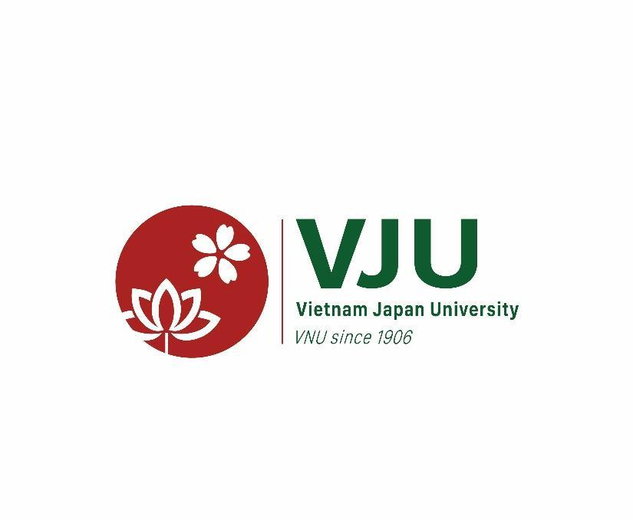 | For Office Use Only
 | Application ID
POSTGRADUATE ADMISSION 2025
APPLICATION FORM

Last Name

Middle Name

First Name
Please write each letter of your name separately and clearly using the CAPITAL LETTERS of the ALPHABET.
1. Personal Details
Place of Birth  (Province, Country) |  | Date of Birth | Day | Month | Year
Gender | ☐ Male ☐ Female | Nationality
Marital Status | ☐ Single ☐ Married  ☐ Others | Ethnicity
Vietnamese ID card |  | Passport No.

2. Program of Application
☐ Area Studies (Vietnamese Studies) | ☐ Climate change and Development | ☐ Civil Engineering
☐ Area Studies (Japanese Studies) | ☐ Environmental Engineering | ☐ Nanotechnology
☐ Business Administration | ☐ Global Leadership | ☐ Public Policy
Admission method: ☐ Interview ☐ Direct admission
Admission period: ☐ First admission ☐ Second admission ☐ Third admission

3. Contact Details
Address
Phone number
Email

4. Qualification
4.1. Academic Qualification
Please give details of any courses undertaken in higher education (e.g. college/university level) including those are pending awards.
Qualification  (e.g. Bachelor) | Name of Institution  (University/College) |  | Major | Grade Point Average | Completed
 |  |  |  |  | Month |  | Year
 |  |  |  | /
 |  |  |  | /
4.2. Language Qualification
Please provide language qualification test results in accordance with your applied program’s requirements (if available)
Language  (e.g. English, Japanese) |  | Qualification  (e.g. IELTS, TOEFL, JLPT) |  | Result  (e.g. 8.0, 50, N2) |  | Date of Exam  (dd/mm/yyyy)

5. Scientific Research Activities (if any)
Please give details of any research activities and scientific works including published and pending publish.
※ Applicant can write on a separate A4 paper.
Research title | Prize  (First/second/third/consolation) | Awarding organization  (MOET/VNU/University/School)
Paper title | Publisher | Categories

6. Work Experience
Please give details of your work experience (if any), including name and address of employer(s), position held.
Dates:  From  To | Position held: | Name and address of employer:
Dates:  From  To | Position held: | Name and address of employer:
7. Statement of Purpose
※ For Master’s Program in Civil Engineering, applicant must (1) write an essay in English on why you wish to study at VJU and your future plans; and (2) indicate clearly which field of interest by choosing one of seven fields as follows:
☐ Urban and Transportation Planning ☐ Structure Engineering ☐ Geo-technical Engineering ☐ Advanced Material Engineering ☐ Transportation Engineering ☐ Project Management ☐ Construction Engineering (Civil and special constructions)
※ For Master’s Program in Climate change and Development, please answer the following questions in about 300 words:
- If you did graduate study/research in the undergraduate course, write the summary of your graduate study/research. If you did not, write what you have acquired (or mastered) in the undergraduate course or after the graduation. Do you think how those you have studied so far can be applied for the study/research of climate change and development?
- Why do you want to study in the Master’s program of Climate change and Development in VJU? What is the career that you want to pursue after graduation?
- What is the theme/topic you want to research? What is the significance of the research in the context of climate change and development? What data and/or what methods will you use for the research?
※ For Master’s Program in Environmental Engineering, please answer the following questions in about 500 – 1000 words:
- Write the summary of your graduate study/research (if any) or what you have acquired in the undergraduate course/after the graduation and their application to the field of environmental engineering?
- Why do you want to study in the Master’s program of Environmental Engineering in VJU? What is the career that you want to pursue after graduation?
- Briefly describe the theme/topic you would propose for your master’s graduate research, the significance of the research, methodology and data collection plan (if any) for your research.
※ For Master’s Program in Area Studies (Japanese Studies), please answer the following questions in about 500 – 1000 words:
1. What kind of books on Japanese Studies did you read? Please list the author(s) and the title of them.
2. If you wrote graduate thesis in the undergraduate course, please write the summary of it.
3. What is the theme or topic you want to research? What is the significance of the research in the context of Japanese Studies in the world? What data and/or what method will you use for the research?
※ For other Master’s Programs, please write an essay in English on why you wish to study at VJU and your future plans.

-----------
Please kindly provide your statement in the space provided below.
There is no constraint on the length, and you are welcome to utilize additional paper if necessary.

……………………………………………………………………………………………………………….
...…………………………………………………………………………………………………………….
………………………………………………………………………………………………………………..

Disclaimer
I certify that all the information on this Application Form is true and correct to the best of my knowledge.
I acknowledge that Vietnam Japan University has the right to refuse my admission or cancel a student’s scholarship in the case of misrepresentation or omission of significant information.
I hereby undertake to strictly comply with the laws and regulations of the Vietnamese Government and the regulations of educational institutions and accommodation providers throughout my stay in Vietnam.

Signature: Date:

Please send your completed Application Form and supporting documents to:
Recipient: Academic and Student Affairs Office, VNU Vietnam Japan University.
Address: R.510, 5th Floor, My Dinh Campus, Luu Huu Phuoc Street, Cau Dien Ward, Nam Tu Liem District, Hanoi, Vietnam.
Tel: (+84-24) 73 06 60 01 (Ext: 5093)
Hotline: (+84) 966 954 736/ (+84) 96 96 38 426
Email: admission@vju.ac.vn

